Resource Partners
EDC has assembled a dynamic and strategic team of partners to assist in the implement-ation of dot-EDU.

Core Partners of dot-EDU
Education Development Center, Inc. (EDC)
Academy for Educational Development
The Concord Consortium
Howard University
Michigan State University (MSU)
Prince George's County Community College

Private Sector Partners
Intel Corporation
IBM Corporation
Sun Microsystems
ThinkQuest, Advanced Network Systems

Resource Institutions
CPAL
Classroom Connects
Council for Basic Education
Earthwalk Communications, Inc.
I*EARN
UPENN I.L.I.
INCRE
INNOTECH
IREX
Monterrey Institute of Technology
Media Bridge
MIT Media Laboratory
NIIT
Omar Dengo Foundation
Pacific Resources for Education and Learning
Real World Productions
SchoolNet/Namibia
University of Pittsburgh
World As A Classroom
World Computer Exchange
World Education
World Links
WorldSpace Foundation

dot-EDU is a “Leader with Associates” cooperative agreement (no. GDG-A-00-01-00011-00) of the United States Agency for International Development (USAID).

dot-EDU is funded by the Bureau for Economic Growth, Agriculture and Trade, Office of Energy and Information Technology (EGAT/EIT), Office of Education (EGAT/ED) and Office of Women in Development (EGAT/WID), and other USAID bureaus, offices and missions. dot-EDU is operated by the Education Development Center (EDC) and other resource partners.

Contacts

Education Development Center
William Wright, Director
Tel: 202-572-3753
Fax: 202-223-4059
wwright@edc.org

Academy for Educational Development
Jeffrey Goveia, Deputy Director
Tel: 202-572-3766
Fax: 202-223-4059
jgoveia@aed.org

United States Agency for International Development
Stephen Tournas, Education Specialist
EGAT/EIT/IT
Tel: 202-712-0154
Fax: 202-216-3229
stournas@usaid.gov






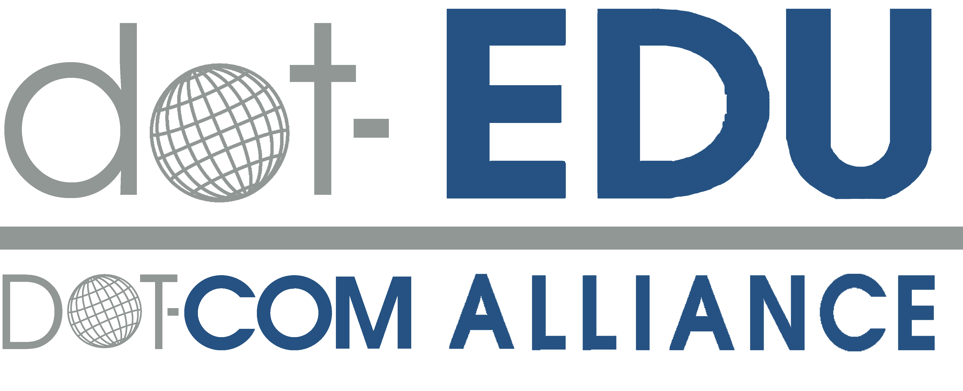

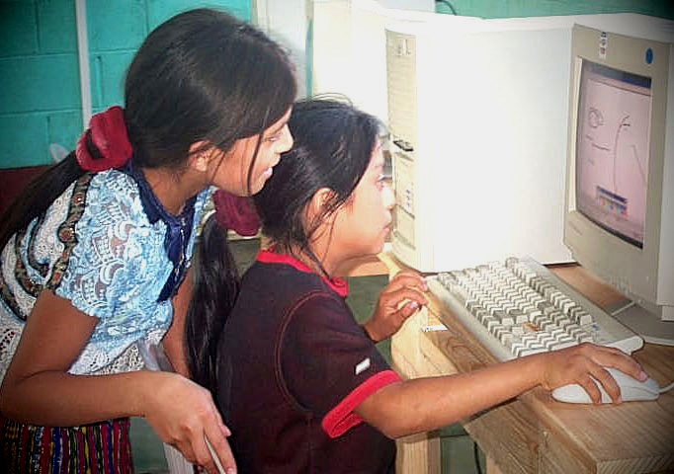





Project Website:
www.dot-com-alliance.org

Grantee Website:
www.dot-edu.org
www.dot-com-alliance.org

Project Website:
www.dot-com-alliance.org

Grantee Website:
www.dot-edu.org
www.dot-com-alliance.org

Project Website:
www.dot-com-alliance.org

Grantee Website:
www.dot-edu.org
www.dot-com-alliance.org

www.dot-edu.org
www.dot-com-alliance.org

Improving learning systems through information and communication technologies

The recent strides made globally in access to information, knowledge and learning show the increasingly important role of information & communication technology (ICT) as a facilitator for educational change. Yet, many still lack access to these new learning technologies—in particular, girls and women in developing countries, who could benefit most. USAID-funded ICT pilots provide “digital opportunity” for developing countries to improve their learning systems in innovative ways that promote economic growth.

What is dot-EDU?

USAID has launched three cooperative agreements to meet development objectives through the use of ICT under a mechanism called the Digital Opportunity through Technology and Communication Partnerships, or DOT-COM Alliance. Through more than seventy-five public, private, university and NGO partners, DOT-COM makes available to USAID missions, bureaus and offices a wealth of institutional expertise. “dot-GOV” is the cooperative agreement that focuses on telecom policy; “dot-ORG” focuses on increasing access to ICT.

dot-EDU, implemented by the Education Development Center (EDC), is the cooperative agreement that helps USAID missions strengthen education and learning systems.

EDC and a number of resource partners bring enormous talent and experience in using information technology to improve learning.

Challenges

dot-EDU applies ICT to address a wide range of educational challenges, including:

- meeting the critical need for pre- and in- service teacher training, especially in the context of the impact of HIV/AIDS
- reducing the isolation of educators and students in remote or rural areas
- increasing access to educational resources and teaching materials
- introducing a student-centered approach to learning and teaching
- improving education for indigenous peoples in native languages
- meeting the needs for education in crisis situations
- meeting the needs for non-formal and life-long learning and training among disadvantaged populations



Out-of-school youth in Zambia learn through Interactive Radio Instruction (IRI)

Solutions

All technology solutions are context-

specific and designed from needs-based assessments. The range of tools and applications include:

- online learning
- school-to-school partnerships
- interactive multi-media instructional materials in local languages
- interactive radio instruction (IRI) and other broadcasting models
- digital production and editing of educational mass media
- ICT-supported workforce development applications

- ICT-supported leadership training for educational administrators
- school-based ICT educational resource centers and telecenters

- educational management information systems

The Process

dot-EDU is available to USAID Bureaus and Missions worldwide. To start the buy-in process, Missions should contact either the USAID CTO (Cognizant Technical Officer) for dot-EDU, Stephen Tournas, or EDC Project Director, William Wright (see Contacts on reverse).

Due to its status as a pre-competed award, dot-EDU staff, consultants, and resource partners can be available to assist USAID in developing concepts for potential dot-EDU activities.

